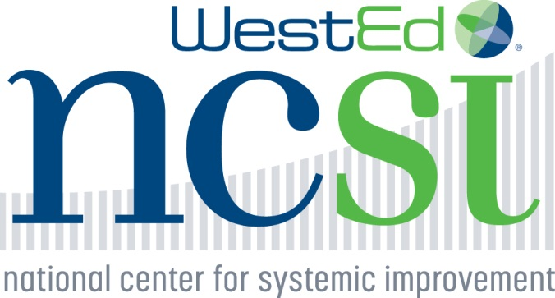 

**Early Intervention Scenario**

During an annual review of family outcomes survey data, the State Part C State Systemic Improvement Plan (SSIP) stakeholders’ group noticed relatively low rates of families reporting that the early intervention (EI) system helped them learn how to effectively communicate their children’s needs. The representative of the state’s Parent Training and Information Center (PTI) on the SSIP Stakeholder Team shared their PTI data on families transitioning from EI to preschool special education, which indicated that a large number of families had not learned how to effectively communicate their child’s needs. Part C system leaders and stakeholders held strong beliefs that the capacity of families to be able to communicate their children’s abilities and challenges was crucial to receiving appropriate services leading to improved child outcomes. Based on the data, and these beliefs, the group selected the State-Identified Measurable Result (SIMR) for the state.

The State Part C leaders arranged for training on implementation science for state staff and the SSIP Stakeholders’ group, including representatives of the PTI and other family members, early intervention providers, as well as referral sources including healthcare providers and others. Following this training, the stakeholders brainstormed improvement strategies in the following areas:

* Increasing knowledge of parents, healthcare providers and early childhood providers including EI providers and state staff;
* Providing parent and professional development on evidence-based/research-supported practices; and,
* Making needed changes in state policies and procedures, including fiscal enhancements, to maximize revenue and support the implementation of evidence-based/research-supported practices.

These improvement strategies were reviewed and organized by the internal Part C team between stakeholder meetings, and then presented to the stakeholders for review. The Part C team had also consulted with several TA centers to identify evidence-based/ research-supported practices relevant to their SIMR, and brought the results of their discussions back to the stakeholders for consideration.

The SSIP stakeholders were committed to ensuring that the improvement plan that was developed had a strong chance of success, both in terms of widespread implementation and outcomes achieved.

Although the stakeholders had been provided with an overview of implementation science, most did not have experience in using IS frameworks. They raised several concerns about whether the state Part C system had the infrastructure and resources to implement evidence-based/research-informed practices with fidelity statewide. How could all the EI providers receive the necessary training? What would happen if the EI providers did not “buy in” to these new approaches? How would parents be informed, and how would they respond? How could referral sources, such as healthcare and child care providers, be brought on board?

Understanding the crucial role of stakeholders in the process, the state Part C staff worked with EI provider agencies, healthcare providers, childcare providers and the PTI to convene groups of EI providers, healthcare providers, childcare providers, and parents, respectively, to discuss the data, the SIMR that had been chosen, the plan that had been developed, the effective practices that had been selected for implementation, and the process that was being proposed for implementation. They asked the participants to share their ideas about the plan, including their perceptions about the feasibility of implementation and recommendations to address any barriers they identified. This information was brought back to the larger stakeholders’ group for review and processing. Based on this information, the plan was revised, including adding provisions for greater leadership in implementation by provider agencies (EI, healthcare, childcare) and the PTI to help promote buy-in of practitioners and families.

Exploration Questions:

1. What steps did the Part C system take that indicated use of:
   1. Leading by Convening to support their work?
   2. Implementation science to support their work?
2. What next steps might the team take:
   1. Through the lens of implementation science?
   2. Through the lens of Leading by Convening?
   3. Through the lens of both?
3. What do you think the strengths/barriers will be to using both together?