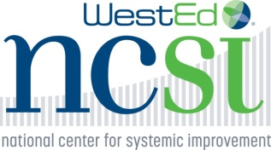 

**Age/Grade Span Scenario**

The state team has selected the stages of implementation science (IS) to organize the implementation of an evidence-based reading strategy that will focus on students with disabilities in grades 3-5, primarily those with a learning disability in reading, to improve their literacy. The intended result is a reduction in the performance gap in reading between students with disabilities and those who do not have a disability as demonstrated by improved scores on state achievement testing. Over time, the effort is expected to improve the graduation rate among students with learning disabilities.

As efforts start in the exploration stage of IS, several concerns are forwarded.

* Who will take the results of the team’s work to *the field*? The concern quickly becomes: How do we get 600+ local school districts to implement and sustain the strategies, interventions and use of an EBP in reading with fidelity over time and across all settings? How big of a team would be required and how would it be funded?
* Will the focus on reading translate to improved graduation, or are other measures and people required to achieve a difference in graduation rate?

Local control is the accepted practice for all education related efforts in this state. The state education agency imposes little to no requirements beyond the mandates required by federal law and those tied to funding. In this context, and with no funds or new hires to complete this initiative, the team looks to Leading by Convening (LbC) to see how they might engage the local school districts to help develop, and then use, the implementation science frameworks to implement the reading strategies selected.

Exploration Questions:

1. What steps did the team take that indicated use of:
   1. Leading by Convening to support their work?
   2. Implementation science to support their work?
2. What next steps might the team take:
   1. Through the lens of implementation science?
   2. Through the lens of Leading by Convening?
   3. Through the combined lens of both?
3. What do you think the strengths/barriers will be to using both together?
4. If the focus on early grades is to translate into graduation at a later point, how should the team be thinking about:
   1. Programs and services prior to the target grades and after the targeted grades?
   2. Implications for both IS and LbC?