Effective Coaching of Teachers: Fidelity Tool Rubric

Purpose of the Fidelity Tool
Like any other educational innovation, the coaching of teachers must be used with fidelity in order to achieve its intended outcomes. Although fidelity is often thought of as adherence to the “key ingredients” of the innovation, it also includes aspects such as quality, responsiveness of the participants (e.g., coach responsiveness to teacher needs), and dose.
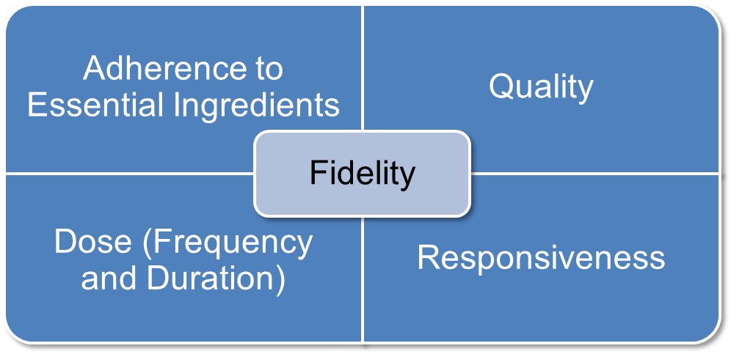
This means that fidelity in coaching should continuously adhere to the effective practices of observation, modeling, delivery of performance feedback, and use of alliance-building strategies. Furthermore, coaching should occur with sufficient frequency and duration, ensure that teachers are engaged with the coaching session such that their needs are being met, and be of high quality.
This tool can be used to help measure the fidelity of coaching so that these data can be used by coaches and other educators to continuously improve upon how coaching occurs. However, this tool should not be used to formally evaluate coaching practice or used in a manner that is not supportive of educators serving in the role of coach. In addition, this tool is intended to be used in conjunction with several other resources:
- Effective Practices for Coaches. The module summarizes effective coaching practices.
- Measuring the Fidelity of Coaching. The module provides a summary of why fidelity data on coaching are important. The module also describes the process for collecting and using coaching fidelity data.
- Effective Coaching of Teachers: Fidelity Tool Worksheet. The worksheet can be used to record coaching fidelity data.
- Effective Coaching of Teachers: Completed Sample of Fidelity Tool Worksheet. This sample provides an example of how the fidelity tool worksheet may be completed and used.
- Effective Coaching: Improving Teacher Practice and Outcomes for All Learners. This brief, and the accompanying infographic Effective Coaching Practices, synthesizes research on coaching and offers a framework of effective coaching practices that should be central to the everyday work of coaches.
- Implementation Guide for Effective Teacher Coaching. The purpose of this guide is to help practitioners systematically implement effective coaching practices. If coaching is designed to improve teaching practice and learning outcomes, it is important to examine how it is implemented.

Directions for Use
- Review the section “Directions for Use” on the Effective Coaching of Teachers: Fidelity Tool Worksheet and the companion Effective Coaching of Teachers: Completed Sample of Fidelity Tool Worksheet to gain an understanding of the overall process of collecting and sharing coaching fidelity data. You may also find it helpful to watch the online modules, Effective Practices for Coaches and Measuring the Fidelity of Coaching.
- Read this document to become familiar with the information contained in the rubric. Note the following:
  - Coaching practices (e.g., observation, modeling, performance feedback, and alliance-building strategies) will be measured for adherence, quality, dose, and responsiveness.
b. For the “adherence” and “quality” columns, the observer checks the appropriate boxes (e.g., yes, no, not applicable). For the “dose” and “responsiveness” columns, the observer measures coaching practice on a scale of 1 to 3, where 1 is the low score and 3 is the high score.
c. If modeling was not needed during the session, check and circle the corresponding NAs. This will ensure that the total possible score reflects the fact that modeling was not needed.
  - To calculate the percentage of coaching fidelity: If modeling occurred, or if modeling was needed but did not occur, calculate the fidelity of coaching practice on page 8 of the fidelity tool worksheet. If modeling was not needed during the session, check the box marked “N/A” on page 5 of the worksheet, and circle “N/A” in each cell of that row. Calculate the fidelity of coaching practice on page 9 of the worksheet.
- Complete steps 1–4 from Effective Coaching of Teachers: Fidelity Tool Worksheet, revisiting this rubric and the other tools as needed.
Rubric
Coaching Practice | Adherence | Quality | Dose | Responsiveness
Observation: Watching the teacher in the classroom environment use a specific program, intervention, or practice  Practice of interest:  _________________ | - No (0 points)  - Yes (1 point) | Check the box that applies to the session:  - Coach not positioned to observe the teacher or students  (0 points)  - Coach positioned to observe either the teacher’s practice or the students, but not both (1 point)  - Coach positioned to observe the teacher and students  (2 points) | 1: Observation of teacher is too brief and occurs too infrequently for coach to understand how teacher uses practice of interest with students  2: Observation of teacher is either too brief or too infrequent for coach to understand how teacher uses practice of interest with students  3: Observation is neither too brief nor too infrequent for coach to understand how teacher uses practice of interest with students  Additional Information:  Number of minutes coach observes teacher:__________  Number of times coach reports observing a teacher per month:  _______________ | 1: Coach did not observe teacher using the practice of interest and did not observe during the predesignated time  2: Coach either observed teacher during predesignated time or when teacher was using practice of interest, but not both  3: Coach observed teacher during predesignated time and when teacher was using practice of interest
Modeling (also referred to as demonstration): Showing the teacher how to use a specific program, intervention, or practice of interest when the teacher is unfamiliar with the practice or uses it incorrectly  Practice of interest:  ___________________ | - Not applicable  - No (0 points)  - Yes (1 point) | Check the box that applies to the session:  - N/A: Modeling was not needed by the teacher  - Coach incorrectly models the practice (0 points)  - Coach correctly models practice of interest (1 point)  - Teacher is given an opportunity to use practice of interest after coach models (2 points) | N/A: Modeling was not needed by the teacher  1: Modeling is either too long or too brief and is infrequent, such that teacher is not able to correctly replicate the practice at all  2: Modeling is too long/too brief or is infrequent, such that teacher is able to correctly replicate a few elements of practice but not majority of practice  3: Modeling is of sufficient duration and frequency that teacher is able to replicate entire practice correctly  Additional Information:  Number of opportunities where modeling should have occurred but did not:  _________________ | N/A: Modeling was not needed by the teacher  1: Coach modeled a different instructional strategy than the practice of interest, and what was modeled was unrelated to practice of interest  2: Coach modeled an instructional strategy that was related to practice of interest, but was not practice of interest  3: Coach modeled practice of interest
Performance Feedback: Presenting formal or informal data about the teacher’s use of a specific program, intervention, or practice  Practice of interest:  ____________________ | - No (0 points)  - Yes (1 point) | Check all that apply to the session (1 point per checked box):  - Based on the teacher’s practice (e.g., an EBP, a classroom management practice)  - Specific  - Positive  - Corrective (if warranted), or corrective was not warranted (1 point)  - Timely (within 1–2 days)  - Additional Information:  How was feedback provided? (e.g., verbal, anecdotal note, graphical)  ___________________  When was it provided? (e.g., during preobservation, postobservation conference, and/or in the moment of teaching)  ___________________ | 1: Less than 25% of the performance feedback was positive  2: 25%–79% of the performance feedback was positive  3: 80% or more of the performance feedback was positive  Additional Information:  Number of performance feedback statements made by coach to teacher:  Positive statements:  ___________________  Corrective statements:  ___________________ | 1: The feedback was not related to the practice of interest  2: Coach provided performance feedback but it was only occasionally related to practice of interest  3: Coach provided performance feedback that was consistently related to practice of interest
Alliance-Building Strategies: Using specific strategies that relate to factors of alliance to build a positive relationship in a teacher–coach dyad (factors of alliance include effective interpersonal skills, collaboration, and expertise)  Practice of interest:  ____________________ | - No (0 points)  - Yes (1 point) | Check all that apply to the session (1 point per checked box):  - Restating and summarizing information conveyed by teacher  - Asking open-ended questions  - Affirming difficulty of change  - Using nonevaluative language  - Referring to past accomplishments  - Identifying and working toward teacher’s goals and needs  - Conveying that improved teaching is about teamwork  - Conveying expertise in teaching and deep content knowledge  - Explaining complex concept succinctly | 1: Use of alliance-building strategies is too brief and is infrequent, such that the coach–teacher interaction is negative  2: Use of alliance-building strategies is too brief or is infrequent, such that coach–teacher interaction is occasionally negative, occasionally positive  3. Use of alliance-building strategies is of sufficient duration and frequency; coach–teacher interaction is only positive | 1: Teacher was not engaged in the session  2: Teacher was only occasionally engaged in the session  3: Teacher was consistently engaged in the session
USE THIS FORM TO CALCULCATE FIDELITY OF COACHING PRACTICE IF COACH MODELED DURING THE COACHING CYCLE OR IF MODELING WAS NEEDED BUT DID NOT OCCUR | Points Possible for Column: 4  Points:  ____________ | Points Possible for Column: 18  Points:  _______________ | Points Possible for Column: 12  Points:  _______________ | Points Possible for Column: 12  Points:  _______________
Total Points Earned: ______________________
Total Points Possible: 46
Calculation: Total Points Earned/Total Points Possible × 100 = Percentage of Fidelity of Coaching Practice
__________/46 × 100 = __________________% Fidelity of Coaching Practice
Example:
4 + 14 + 10 + 12 = 40; 40/46 × 100 = 87% Fidelity of Coaching Practice
Comments/Notes:

USE THIS FORM TO CALCULCATE FIDELITY OF COACHING PRACTICE IF MODELING WAS NOT NEEDED | Points Possible for Column: 3  Points:  _____________ | Points Possible for Column: 16  Points:  _______________ | Points Possible for Column: 9  Points:  _______________ | Points Possible for Column: 9  Points:  _______________
Total Points Earned: ______________________
Total Points Possible: 37
Calculation: Total Points Earned/Total Points Possible × 100 = Percentage of Fidelity of Coaching Practice
__________/37 × 100 = __________________% Fidelity of Coaching Practice
Example:
3 + 10 + 9 + 9 = 31; 31/37 × 100 = 84% Fidelity of Coaching Practice
Comments/Notes:

Contributors to Effective Coaching of Teachers: Fidelity Tool Rubric
Suggested citation: Pierce, J. D., & Ferguson, A. (2018). Effective coaching of teachers: Fidelity tool rubric. San Francisco, CA: WestEd.
For additional information regarding content, please contact Ask the NCSI at https://ncsi.wested.org/ask-the-ncsi/. Ask the NCSI is a research and information service provided by the National Center for Systemic Improvement (NCSI). Ask the NCSI is intended to support states to (1) obtain information about evidence-based practices; (2) develop, implement, and evaluate State Systemic Improvement Plans (SSIPs); (3) learn about practices being implemented in other states; and (4) find out what current research says about “what works” to improve results for children with disabilities.
Ask the NCSI will accept information requests from NCSI clients; e.g., state departments of education (Part B) and state lead agencies for the early intervention program (Part C of the IDEA). Our goal will be to provide a response to your request within 5-21 days. For specific technical assistance (TA) requests, states are invited to contact their assigned TA Facilitators.
You may contact NCSI at NCSI@wested.org or 866.664.8471.
We look forward to hearing from you!
The contents of this document were developed under a grant from the US Department of Education, #H326R140006. However, those contents do not necessarily represent the policy of the US Department of Education, and you should not assume endorsement by the Federal Government. Project Officers: Perry Williams and Shedeh Hajghassemail (November 2014).

Where we use the word teacher throughout this document, we include individuals, such as early child care providers, interventionists, and parents, who work with learners in a less traditional educational setting (often the learner’s home), in addition to the individuals, such as prekindergarten through grade 12 teachers, who work with learners in a classroom setting. We use learner to refer to the infants, toddlers, children, and youth with whom these broadly defined teachers work.

